**Design and Analysis of Algorithms Assignment**

**Question 1:**

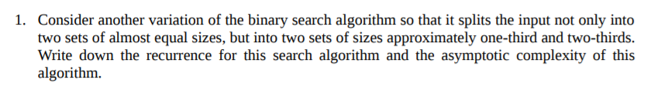

**Answer to Question 1:**

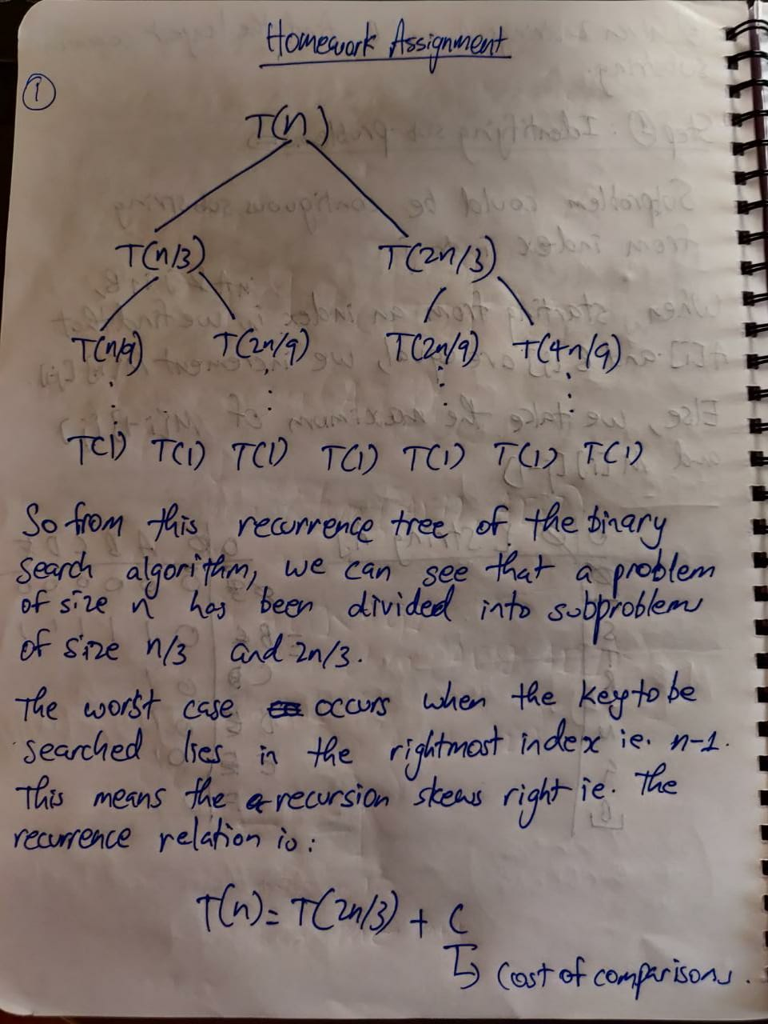PTO

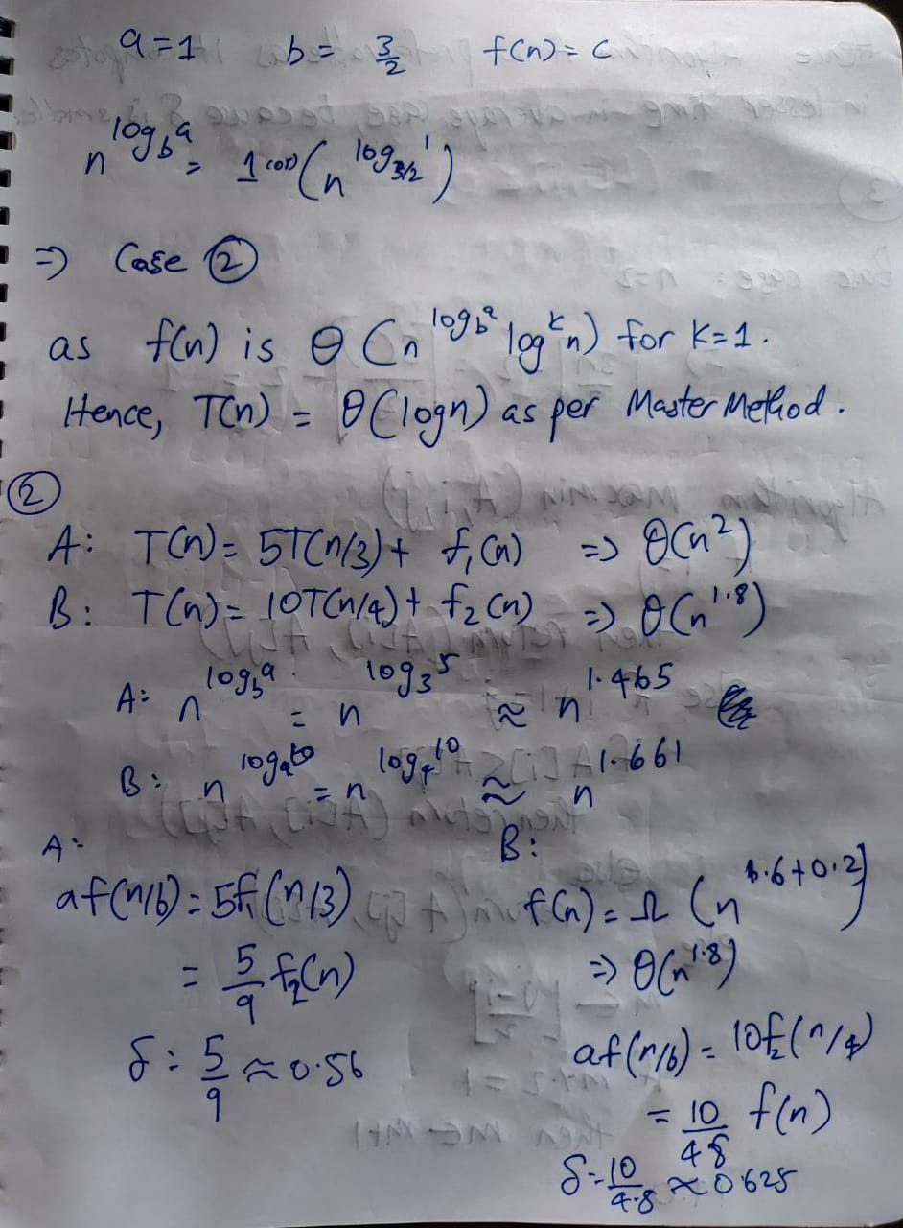

**Question 2:**

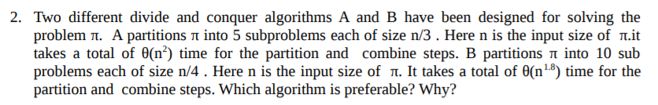

**Answer to Question 2:**



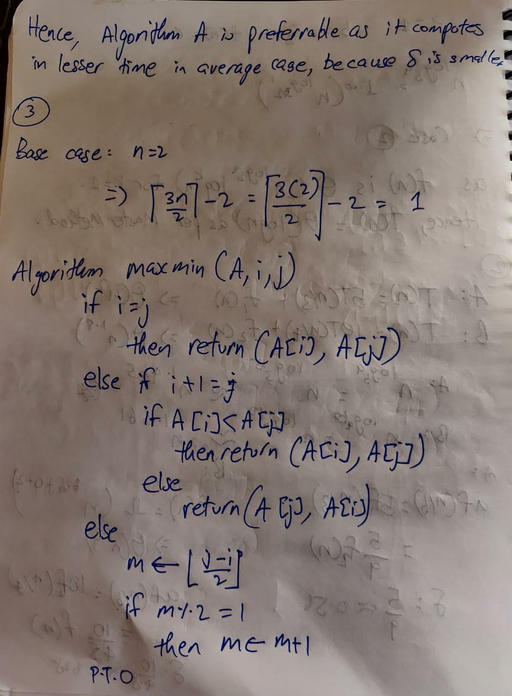

**Question 3:**



**Answer to Question 3:**



PTO

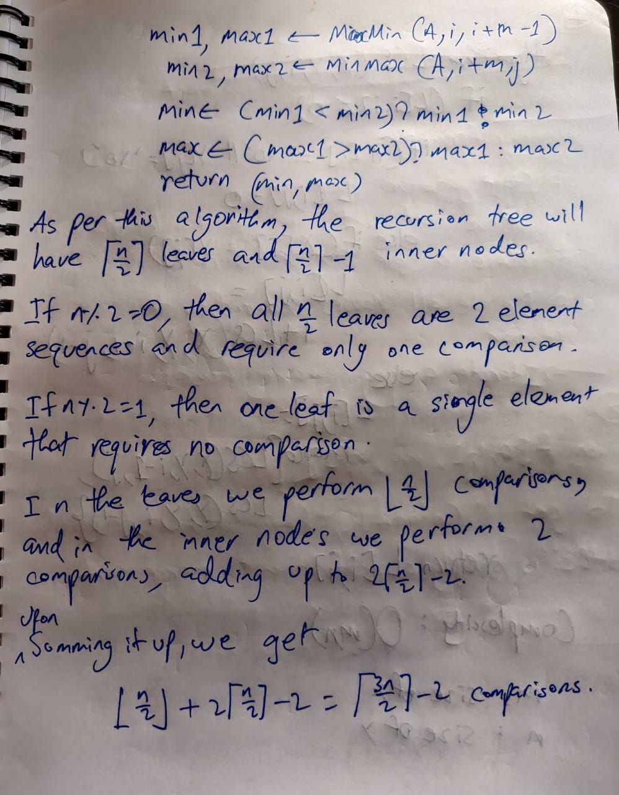

**Question 4:**



**Answer to Question 4:**

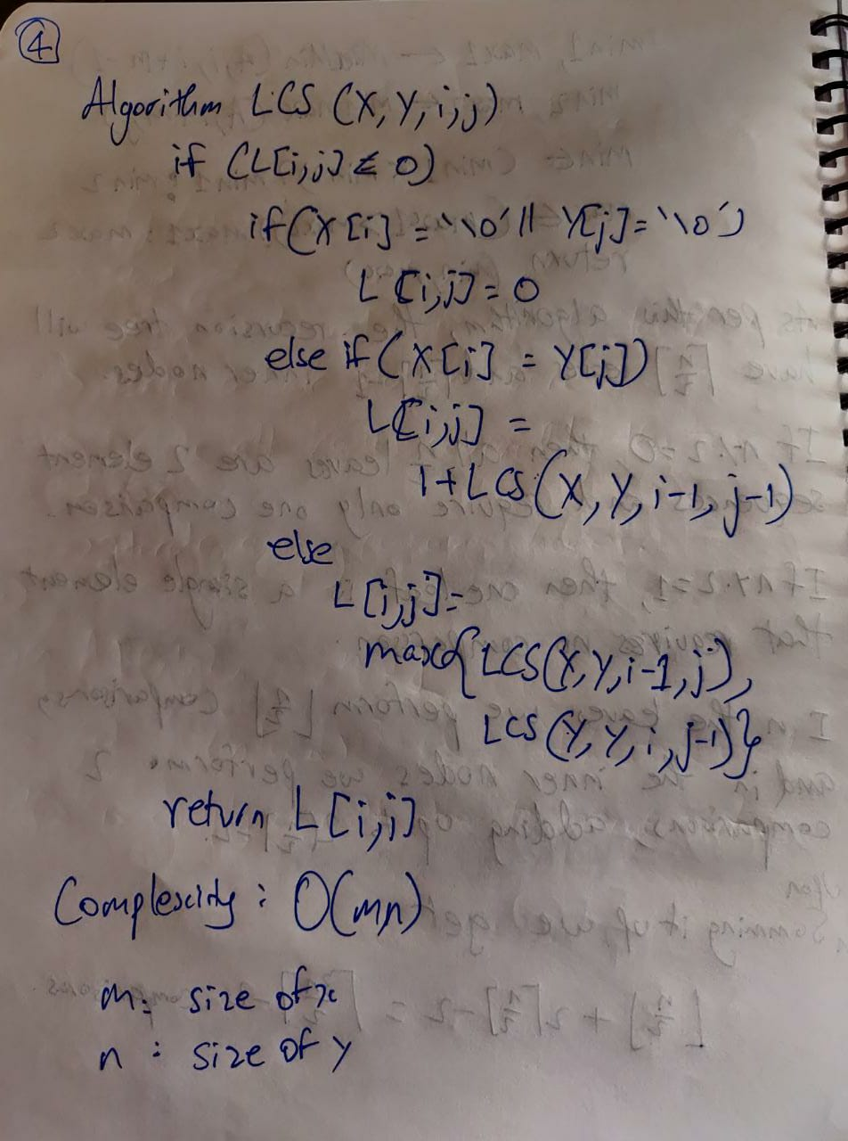

**Question 5:**



**Answer to Question 5:**

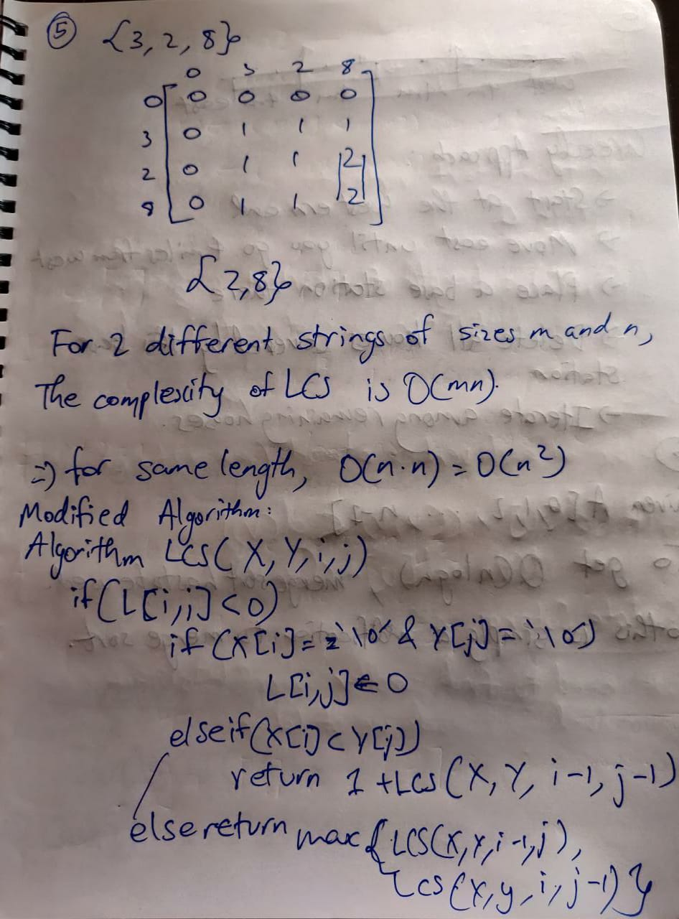

**Question 6:**

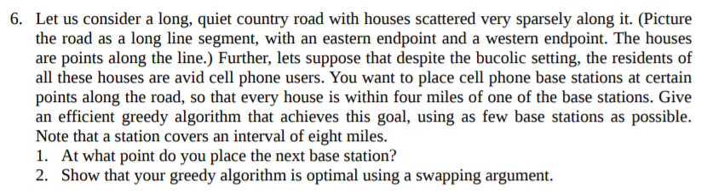

**Answer to Question 6:**

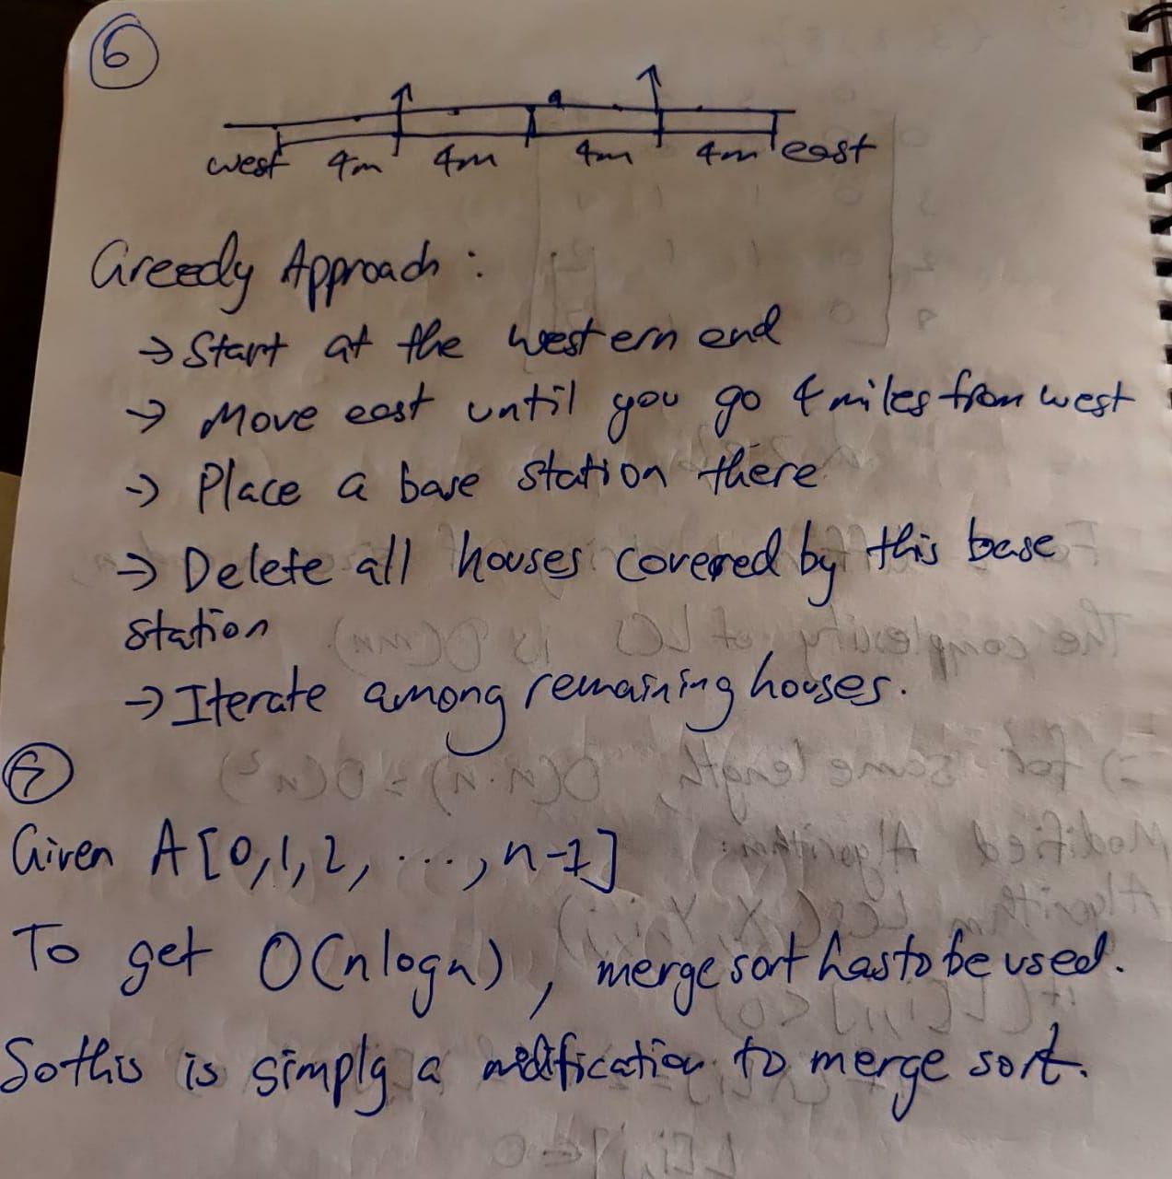

**Question 7:**



**Answer to Question 7:**



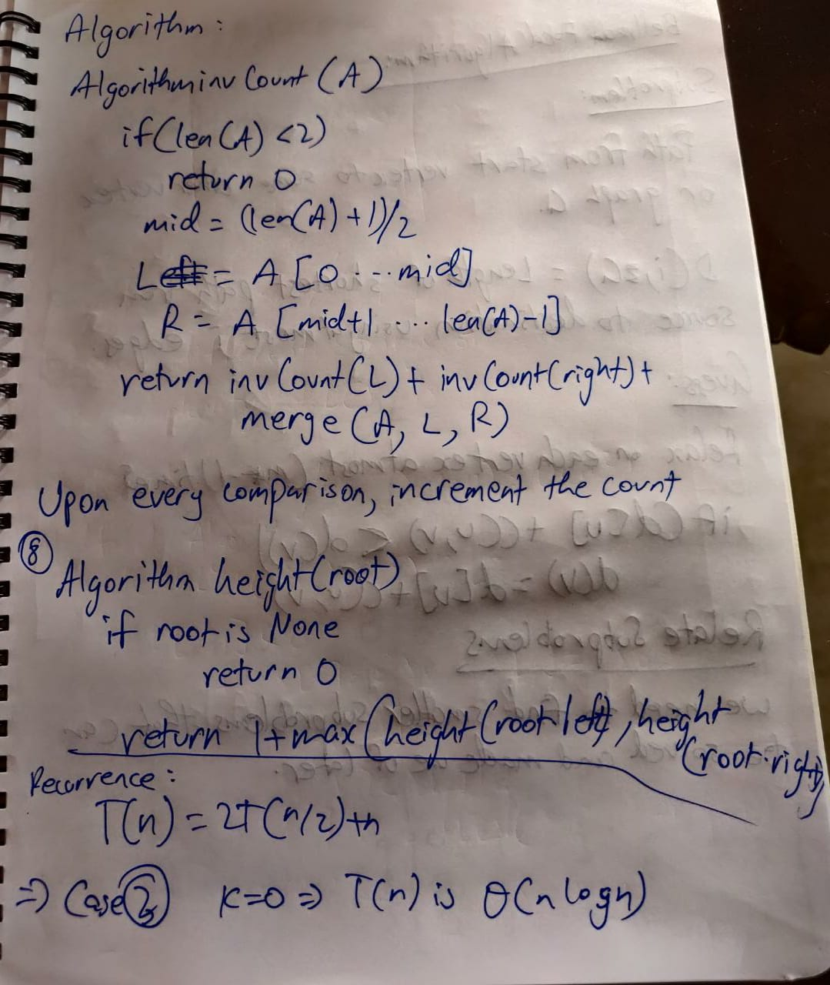

**Question 8:**



**Answer to Question 8:**



**Question 9:**



**Answer to Question 9:**

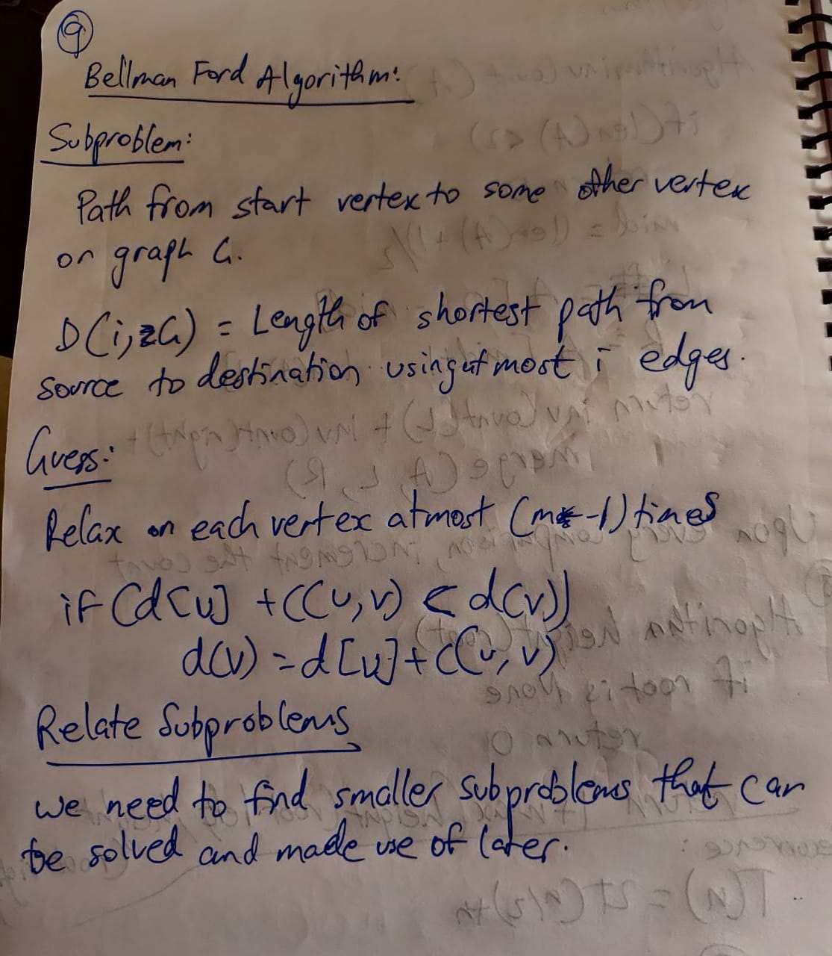

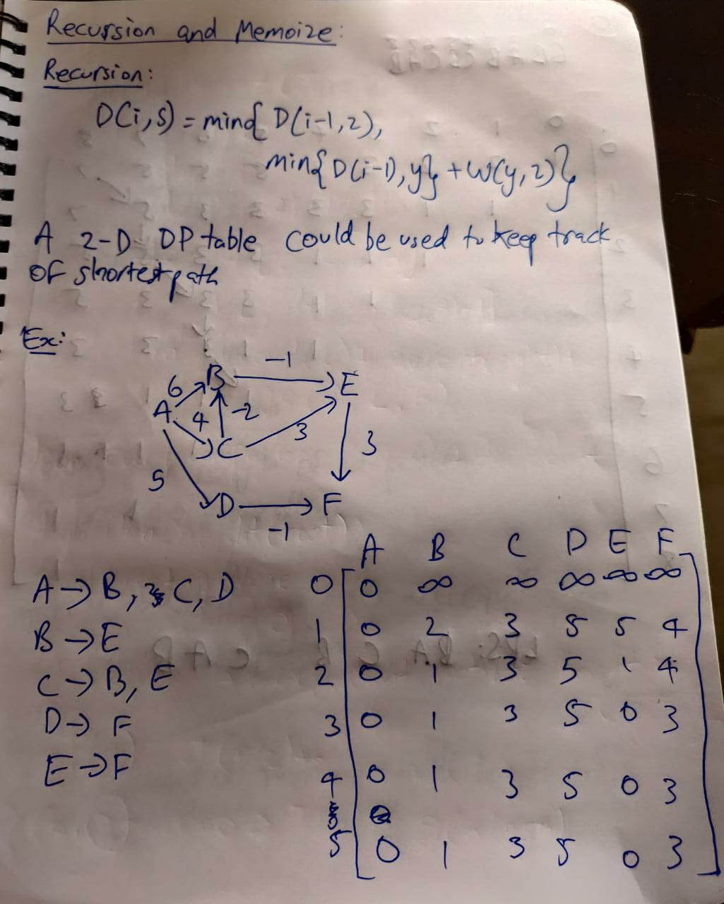

**Question 10:**

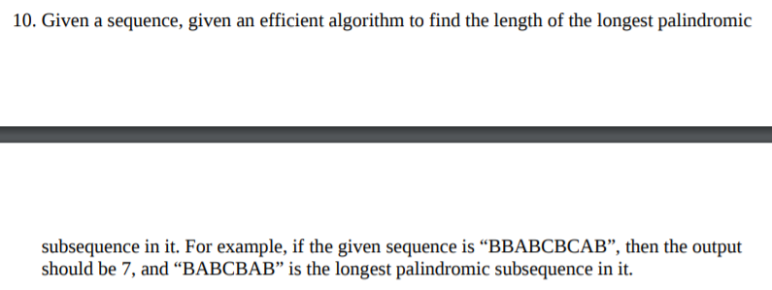

**Answer to Question 10:**

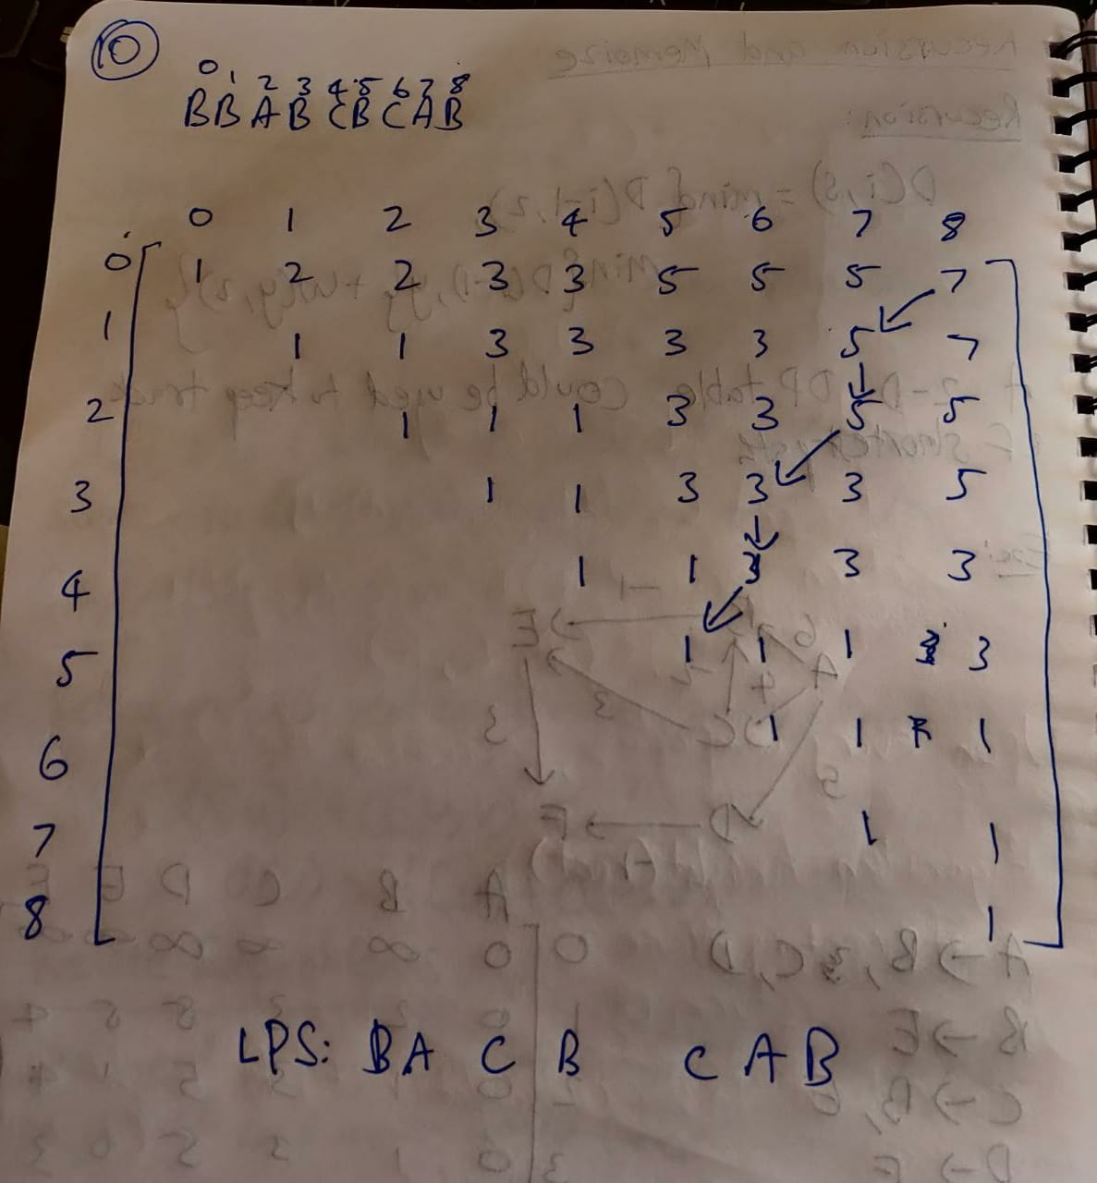PTO

